

South Regional TAFE
Information Statement

A guide to accessing information maintained by South Regional TAFE

This Information Statement for the South Regional TAFE is prepared in accordance with the requirements of Section 94 of the FOI Act.

Each agency is required to prepare and publish an Information Statement.

This Information Statement is subject to annual review.

Contents

Foreword 3
Introduction to the College 4
Scope 4
Structure 4
Training Services 4
Support Service Directorates 5
Participation in the College’s policy making 5
Legislation 6
Freedom of Information operations 7
Freedom of Information applications 7
Documents that can be accessed under the FOI Act 8
Amendment of personal information 8
Are there any costs involved? 9
Timeframe for responding to a request 9
How will I be advised? 9
Can I ask for a review of the decision? 9
Right of review 9
Access arrangements 10
Documents may be purchased 11
Documents may be available free of charge 11

Foreword
This publication is the Information Statement of the South Regional TAFE. It provides an overview of the college so that people may understand the nature of our work and the type of documents that are available. Information contained in this publication is accurate as at September 2023.

The college is committed to comply with the objects and intent of the Western Australia Freedom of Information Act 1992. We endeavour to maximise the availability of documents held by the college to the public, without the need for an application under Freedom of Information (FOI). At the same time, we remain vigilant in protecting the personal and commercial privacy of our clients and staff.

I invite you to contact our Freedom of Information Officer if you have any queries about the FOI process or if you require assistance in applying for information held by the college:

Freedom of Information Officer
South Regional TAFE
PO Box 1224
Bunbury WA 6231
Telephone: (08) 6371 3000
Email: records@srtafe.wa.edu.au

Introduction to the college
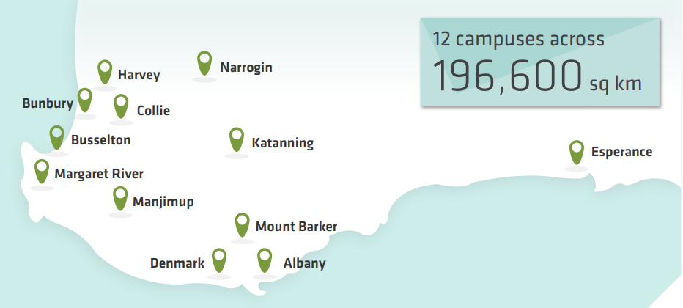

Scope
The college services a regional population of approximately 365,000 through campuses at Albany, Bunbury, Busselton, Collie, Denmark, Esperance, Harvey, Katanning, Manjimup, Margaret River, Mt Barker and Narrogin, offering students ready access to local learning facilities. The demand for training in the Southern Region of Western Australia has been fuelled by strong population growth.

The college is a Registered Training Organisation (RTO) and has in place quality business systems to maintain this RTO status. The college scope is available at the Department of Education and Training, National Register of VET (http://training.gov.au/Home/Tga).

Structure
The accountable authority of the college is the South Regional TAFE Governing Council. The functions, appointment and composition of the Council are prescribed in Division 2 of Part V of the Vocational Educational and Training Act 1996.

The responsible Minister is the Minister for Training and Workforce Development.

Training Services
With approximately 295 courses on scope, training is delivered by the college across a broad range of industry areas. Training Services provides training to approximately 10,000 domestic students through a range of delivery types including employment and institutional based training. The student body includes apprentices, trainees, school students and adults.

The college provides training for International students through a partnership arrangement with TAFE International WA (TIWA). Information on these services is available through the TIWA website (https://www.tafeinternational.wa.edu.au/).

Support Services Directorates
Staff and students in the college are supported by two key support directorates; Corporate Services and Organisational Services.

Corporate Services includes:
- Facilities & Services
- Finance
- Human Resources
- Information Services
- Workplace Health and Safety & Risk

Organisational Services includes:
- Academic Quality
- Planning & Business Services
- Jobs & Skills Centre
- Student Experience
- Student Support Services
- Aboriginal Programs
- Marketing & Communications

Participation in the college’s policy making
To maintain currency and relevancy in its services, the college actively consults and liaises with a wide variety of industry groups, community groups, student bodies and the higher education and school sectors to obtain input into policy formulation.

Client Feedback Forms are available for members of the public, staff and students to provide comment on all matters relating to the college. The Student Engagement Survey and Employer Satisfaction Survey provide statistics on college performance. Industry Skills Councils play an important role in gathering policy-related information from industry and the college consults with Industry Reference Groups (IRG) to provide localised input.

The Aboriginal Education, Employment and Training Committee focuses on developing strategies to deliver more effective education and training services to Aboriginal people.
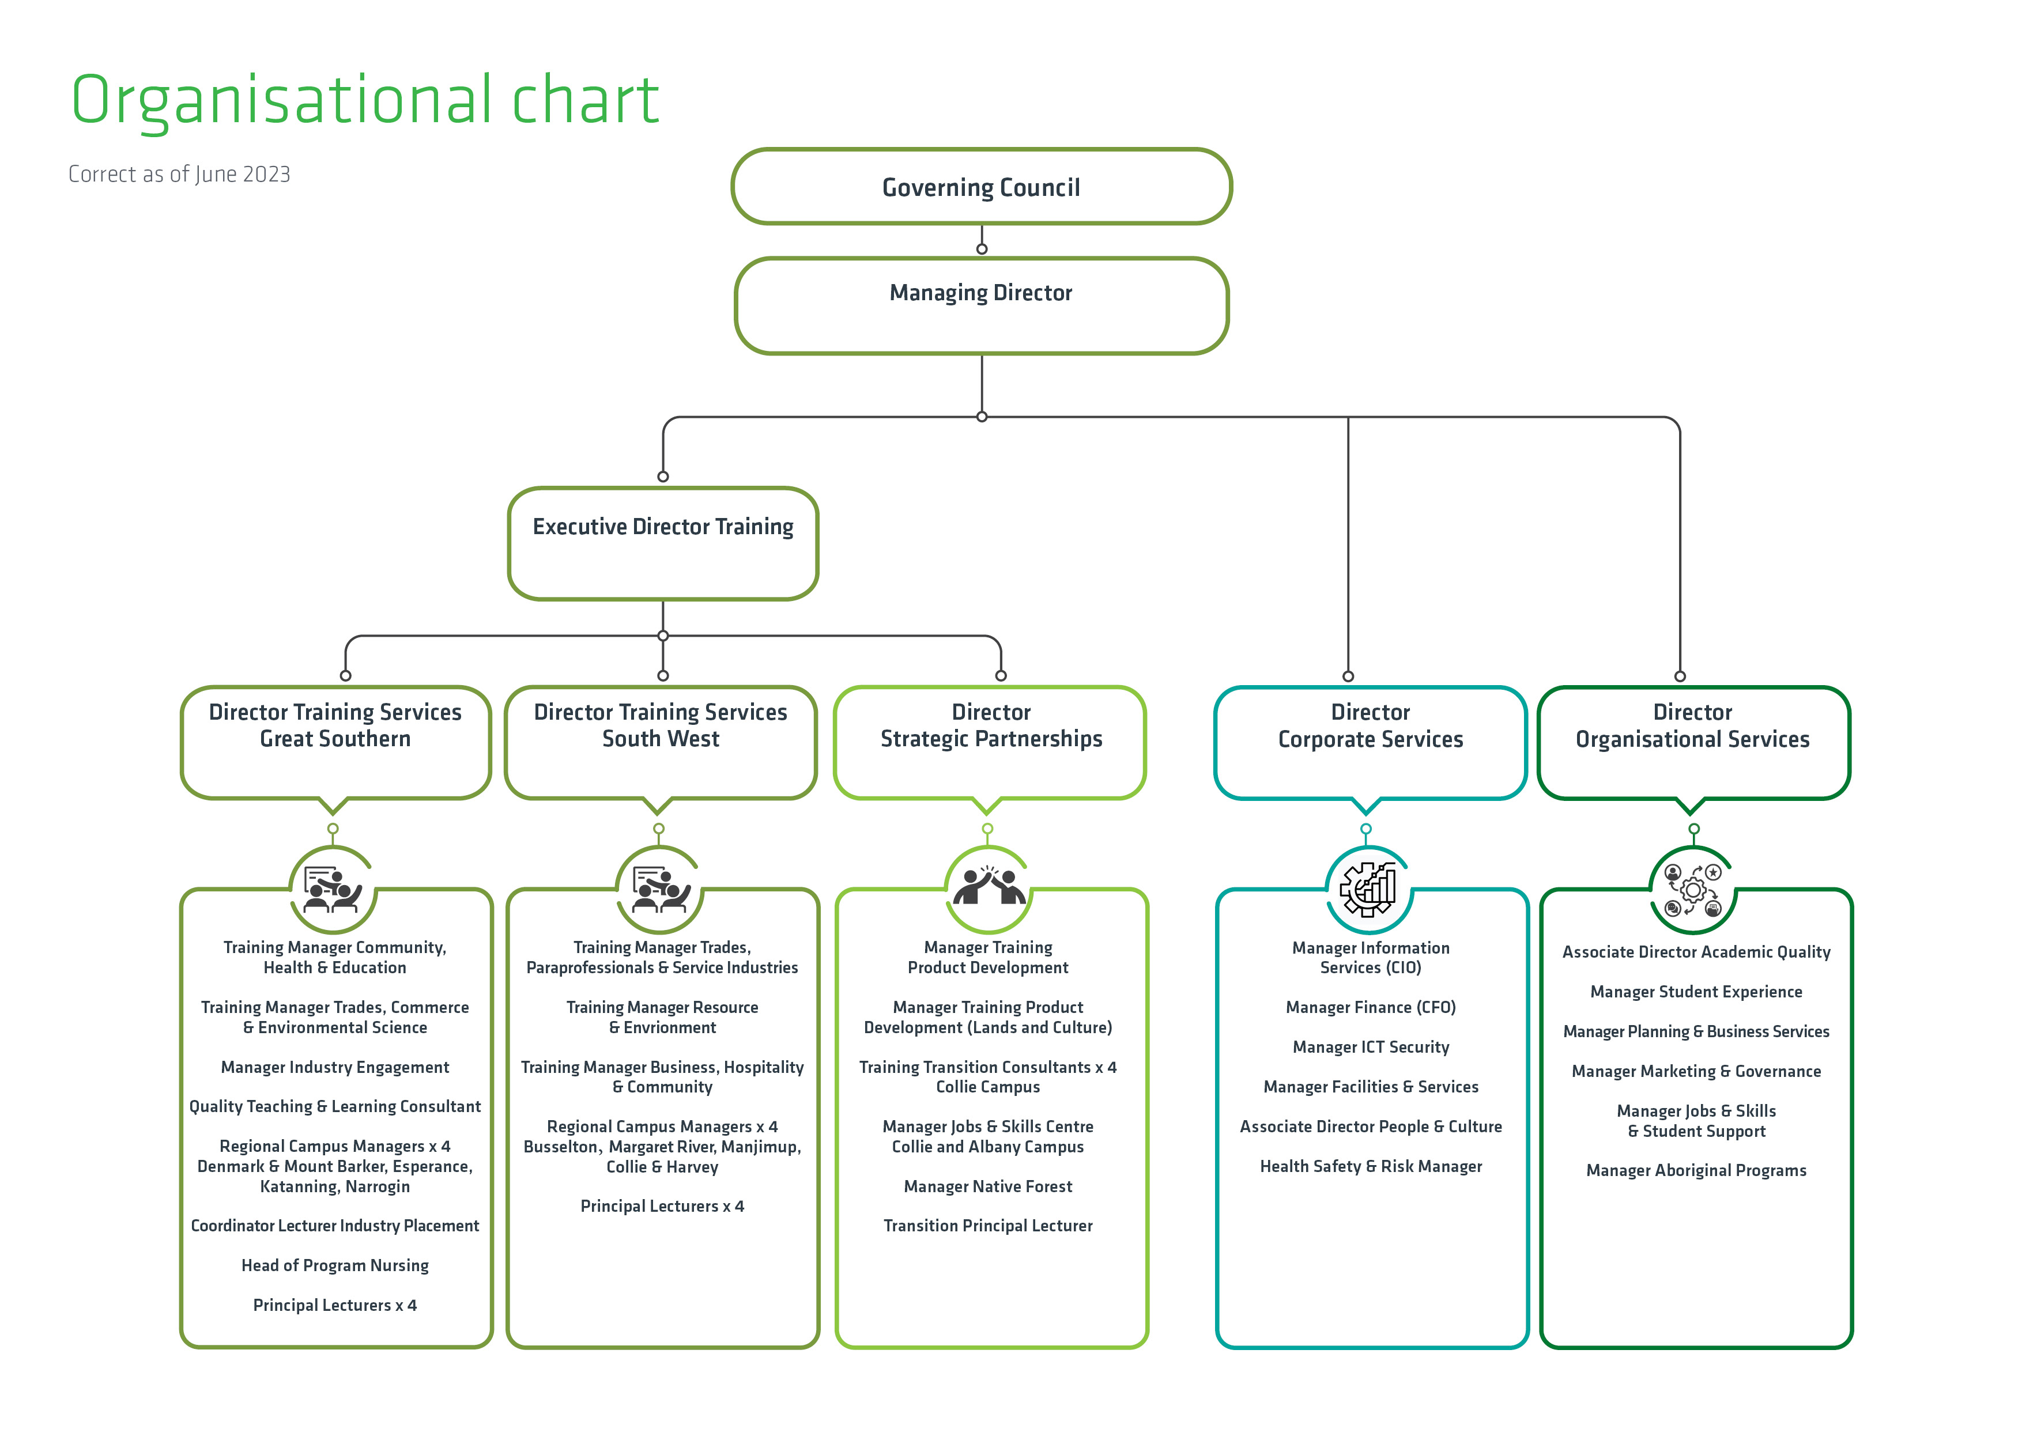
Legislation
The Vocational Education and Training Act 1996 replaced the Colleges’ Act 1978, the Industrial Training Act 1975 and the State Employment and Skills Development Act 1990 and enables delegations of Ministerial powers to the college Governing Council and in turn, to the Managing Director who is the Chief Executive Officer appointed under the Public Sector Management Act 1994.

The current Governing Council comprises of ten members, selected from industry or the community, for a term not exceeding three years. From time to time, the Minister will call for nominations from the local community.

The Western Australian Freedom of Information Act 1992 (the FOI Act) gives you the right to apply for access to documents held by State Public Sector agencies which include: Government Departments, Local Authorities, Statutory Authorities and Ministers.

Agencies are required to assist the public obtain access to documents at the lowest reasonable cost and to ensure that personal information held is accurate, complete, up to date and not misleading. Your right to apply is not affected by any reasons you have for wishing to obtain access, or the college’s belief as to what your reasons are for applying.

Freedom of Information operations
It is the aim of the college to make information available promptly and at the least possible cost and whenever possible documents will be provided outside the FOI process.

If information is not routinely available, the Freedom of Information Act 1992 provides the right to apply for documents held by the college and to enable the public to ensure that personal information in documents is accurate, complete, up to date and not misleading.

Freedom of Information applications
Access applications must:
- Be in writing
- Give enough information so that the documents requested can be identified
- Give an Australian address to which notices can be sent
- Be lodged at the college with any application fee payable

Applications and enquiries should be addressed to:
Freedom of Information Officer
South Regional TAFE
PO Box 1224
Bunbury WA 6231

Telephone: (08) 6371 3000
Email: records@srtafe.wa.edu.au

Applications will be acknowledged in writing and the applicant will be notified of the decision within 45 (calendar) days.

Documents that can be accessed under the FOI Act
The right of access under the FOI Act is a right to access documents, rather than information. The college is not required to create new documents for the sole purpose of providing applicants the information they seek. Decisions under the FOI Act relate to access to documents rather than provide interpretations, clarifications or answers to questions.

The FOI Act defines the word ‘document’ and ‘record’ of the college as: -
- Any paper or other material, including affixed papers on which there is writing
- Any map, plan, diagram or graph
- Any drawing pictorial or graphic work, or photograph
- Any paper or other material on which there are marks, figures, symbols or perforation, having a meaning for persons qualified to interpret them
- Any article of material from which sounds, images or writing can be reproduced whether or not with the aid of some other article or device
- Any article on which information has been stored or recorded, either mechanically, magnetically or electronically that is in the possession or under the control of the College including a document to which the college is entitled access and a document that is in the possession or under the control of an employee of the college in his or her capacity as such an employee

Amendment of personal information
Under the FOI Act, staff, students and the general public may apply to have personal information about themselves held by the college amended, if they believe it is incomplete, incorrect, out of date or misleading. Requests to have documents amended should be directed in writing to the FOI Officer.

Receipt of application must be acknowledged in writing by the FOI Officer.

The decision to allow or refuse amendment of personal information is to be made by the FOI Officer in consultation with the relevant unit manager, depending on the nature of the request.

The college is required to give the applicant written notice of its decision within 30 days (Section 49(2) FOI Act).

The notice is to give details of approved amendment or a statement of reason for the decision to refuse amendment of the personal information.

A simple name and/or address change is handled through our usual process, upon completion of a Change of Contact Details form and/or supply of proof of change.

Are there any costs involved?
No fees or charges apply for personal information or amendment of personal information about you (e.g. your personal details or details of employment etc).

Applications for other documents (i.e. those which are non-personal in nature) require a $30 application fee to be paid when the application is lodged, and there may be other charges imposed by the college as follows:
- $30 per hour of staff time (or pro rata for part of an hour) for dealing with an application (agencies cannot charge for locating the documents within the scope of your request)
- $30 per hour (or pro rata for part of an hour) for supervision by staff when access is given to view documents, or the time taken by staff to prepare a transcript from a tape or make photocopies
- 20 cents per photocopy
- Actual costs incurred by the college for preparing a copy of a tape, film or computerised information, or arranging delivery, packaging and postage of documents

Timeframe for responding to a request
Once the college receives a valid application from you, the college has a maximum of 45 calendar days to make a decision. On average the time taken by agencies is less than this permitted period.

How will I be advised?
Notice of Decision
As soon as possible but in any case, within 45 days the applicant will be provided with a notice of decision which will include details such as:
- The date which the decision was made
- The name and the designation of the officer who made the decision
- If the document is an exempt document the reasons for classifying the matter exempt or the fact that access is given to an edited document
- Information on the right to review and the procedures to be followed to exercise those rights

Can I ask for a review of the decision?
Yes. You will be advised of your rights of internal and external review in the decision sent to you by the college. There are no charges for the conduct of reviews.

Right of review
- Internal Review Rights
If you are not satisfied with this decision, you have a right to apply for an internal review.
An application for internal review must be lodged with this college within 30 days after being given this written notice of decision, and must:
  - Be in writing
  - Provide particulars of the decision to be reviewed
  - Give an address in Australia

There is no lodgement fee for an application for internal review and there is no charge for dealing with an internal review request.

If an application for internal review is received, it will not be dealt with by the person who made the initial decision, or by any person who is subordinate to the original decision maker. The outcome for an application for internal review may result in a confirmation, variation or reversal of the initial decision under review. You will be advised of the outcome within 15 days.
The address for lodgement of an internal review is:
The Managing Director
South Regional TAFE
PO Box 1224
Bunbury WA 6231

- External Review
If you are not satisfied with this decision, you have the right to lodge a complaint with the Information Commissioner seeking external review of that decision. You are required to lodge your complaint with the Information Commissioner’s office within 60 days of receiving this notice.

A complaint to the Information Commissioner must:
  - Be in writing
  - Have attached to it a copy of this decision
  - Give an address in Australia

There is no charge for lodging a complaint with the Information Commissioner’s office.

The address of the Information Commissioner is:
Office of the Information Commissioner
Albert Facey House
469 Wellington Street
Perth WA 6000

Should you have any further queries or require any further information about your review rights at this stage, you may contact the Office of the Information Commissioner on (08) 9220 7888.

Access arrangements
Access to documents can be granted by way of inspection, a copy of a document, a copy of an audio or video tape, a computer disk, a transcript of a recorded, shorthand or encoded document from which words can be reproduced.

Documents may be purchased
Developmental curriculum materials may be available for purchase through negotiations with the relevant unit of the local campus.

Documents may be available free of charge
Application for a re-print of a Certificate of Qualification, Statement of Attainment or a Statement of Academic Record that has been lost or damaged by the student can be made to the college’s administration staff.

The following resources can be obtained free of charge:

Learning Resource Centres and Internet
The South Regional TAFE Learning Resource Centres (Albany and Bunbury Campuses) hold several relevant resources. Access to them is available through the Library catalogue. There is also access to some documents and information through the Internet at the college's homepage http://www.southregionaltafe.wa.edu.au

Reports and publications available free of charge include:
- South Regional TAFE Annual Reports
- Qualification promotional information
- Customer Services Charter
- Customer Services information (e.g. Library user information, careers advice, promotional material)
- Disability Services Plan for Access and Inclusion
- Human Resources information documents
- Strategic Priorities document

Access to the above documents may be obtained through contacting the relevant unit of the college.

Persons requiring further information regarding FOI in general are invited to contact:

Freedom of Information Officer
South Regional TAFE
PO Box 1224
Bunbury WA 6231
Telephone: (08) 6371 3000
Email: records@srtafe.wa.edu.au

Related documents
Privacy Policy

Relevant legislation and references
(Western Australian) Freedom of Information Act 1992
(Australian Government) Freedom of Information Act 1982
South Regional TAFE privacy statement (Website)

Version control
Custodian of document | Version | Date of next review
Director Organisational Services | 16 | 12 months from date of issue

Reference: Id Profile – Western Australian Parliamentary Library – Community Profile

