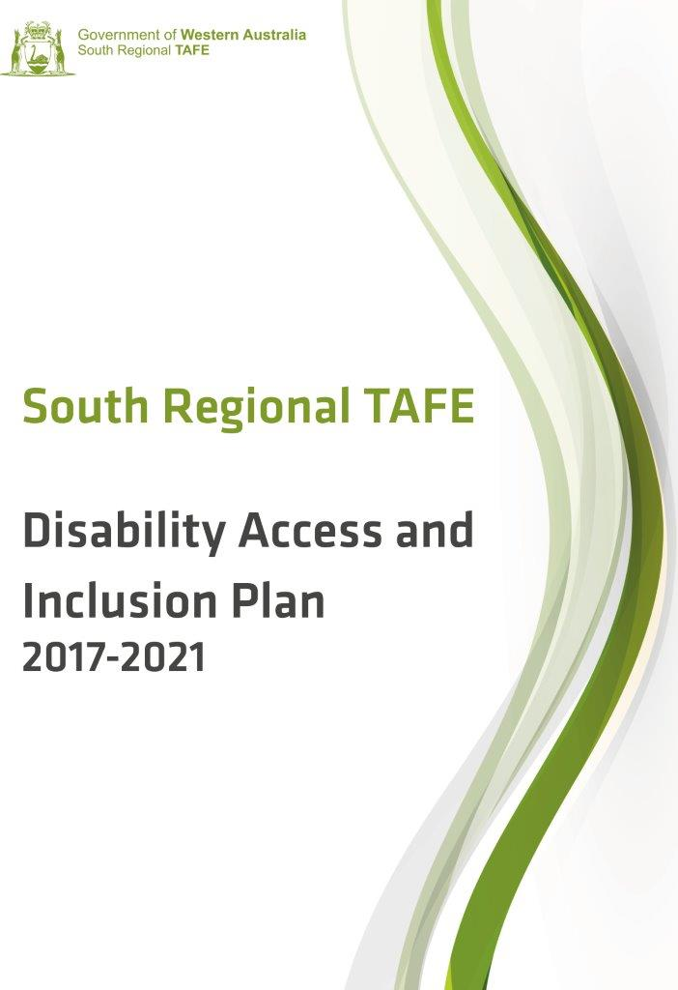

This document is available in alternative formats on request including standard and large print, electronically by email, in audio format on CD and on our website.

Contents
Background 4
Planning for Access and Inclusion 4
Access and Inclusion Policy 5
Development of the Disability Access & Inclusion Plan 2017 – 2021 6
Community Consultation 7
Communicating the DAIP 7
Implementing the DAIP 7
Monitoring, Review and Evaluation 8
Reporting on the DAIP 8
Access and Inclusion Strategies 9

Background
South Regional TAFE (SRTAFE) is the largest provider of publicly funded vocational education and training in the Great Southern and South West regions of Western Australia. South Regional TAFE was formed in April 2016 amalgamating Great Southern Institute of Technology, South West Institute of Technology and incorporating the Narrogin campus of CY O’Connor Institute and the Esperance campus of Goldfields Institute.
The college covers 196,600 sq km and includes 12 campuses located at Albany, Bunbury, Busselton, Collie, Denmark, Esperance, Harvey, Katanning, Manjimup, Margaret River, Mt Barker and Narrogin. The college also provides training through arrangements with schools across the region and at Albany and Bunbury Regional Prisons.
South Regional TAFE offers vocational education and training across a wide range of industry areas from Certificate I through to Advanced Diploma, apprenticeship and traineeship training, articulated pathways to university, entry and bridging programs, commercial and customised training.
Study options include face to face delivery, online, workplace delivery and assessment, Recognition of Prior Learning and through a flexible blended delivery approach.

Planning for Access and Inclusion
Just under one in five people (4.2 million people or 18.5% of Australians) identify as having a disability while 12 per cent of the population are carers for people with disability (Australian Bureau of Statistics, 2014.) For those people with disability, 3.7 million (88%) had a specific limitation or restriction that meant they were limited in the core activities of self care, mobility or communication, or restricted in schooling or employment.
It is a requirement of the Disability Services Act 1993, amended in 2004 that public authorities develop and implement a Disability Access and Inclusion Plan (DAIP) that outlines the ways in which the authority will ensure people with disability have equal access to its facilities and services. This plan must be reviewed at least every five years.
Key legislation underpinning access and inclusion includes the WA Equal Opportunity Act 1984 and the Commonwealth Disability Discrimination Act 1992 (DDA). The DDA makes it unlawful for an educational authority to discriminate against a person with a disability.

The definition of "disability" in the DDA includes:
- Physical
- Intellectual
- Psychiatric
- Sensory
- Neurological, and
- Learning disabilities, as well as
- Physical disfigurement, and
- The presence in the body of disease-causing organisms.
This broad definition is meant to ensure that everyone with a disability is protected.
The DDA covers a disability which people:
- Have now,
- Had in the past (for example: a past episode of mental illness),
- May have in the future (e.g.: a family history of a disability which a person may also develop),
- Are believed to have (for example: if people think someone has AIDS).
The DDA also covers people with a disability who may be discriminated against because:
- They are accompanied by an assistant, interpreter or reader,
- They are accompanied by a trained animal, such as a guide or hearing dog, or
- They use equipment or an aid, such as a wheelchair or a hearing aid.
The DDA protects people who have some form of personal connection with a person with a disability like relatives, friends, carers and co-workers if they are discriminated against because of that connection or relationship.
Disability Standards for Education enacted under the DDA in 2005, set out the obligations of training providers to provide for the rights of people with disability in education and training.
Disability (Access to Premises – Buildings) Standards 2010 which came into effect in May 2011, apply to all new buildings and upgrades to existing buildings used by the public, including employees.

Access and Inclusion Policy
South Regional TAFE values diversity and promotes an inclusive learning and working environment. The college is committed to ensuring that people with disability, their family and carers can access the college’s services and facilities, and employment opportunities providing them with the same opportunities, rights and responsibilities as other people in the community.
The college promotes an environment free from discrimination and harassment, inclusive practices and policies, and college wide responsibility for ensuring equity and access for students and staff with disability.
South Regional TAFE is committed to achieving the seven desired outcomes of its DAIP.
- People with disability have the same opportunities as other people to access the services of, and any events organised by, South Regional TAFE.
- People with disability have the same opportunities as other people to access the buildings and facilities of South Regional TAFE.
- People with disability receive information from South Regional TAFE in a format that will enable them to access the information is readily as other people are able to access it.
- People with disability receive the same level and quality of service from the staff of South Regional TAFE as other people receive from the staff of the college.
- People with disability have the same opportunities as other people to make complaints to South Regional TAFE.
- People with disability have the same opportunities as other people to participate in any public consultation undertaken by South Regional TAFE.
- People with disability have the same opportunities as other people to obtain and maintain employment at South Regional TAFE.
To assist this process the college will:
- Consult with community members, people with disability, their families and carers and disability organisations to ensure that barriers to access and inclusion are addressed appropriately
- Ensure that the college’s agents and contractors work towards the desired access and inclusion outcomes in the college’s DAIP
- Develop and maintain partnerships with community groups and organisations, disability agencies and other public authorities to facilitate the inclusion of people with disability and improve access to the college’s information, services and facilities.

Development of the Disability Access & Inclusion Plan 2017 – 2021
South Regional TAFE’s Disability Access and Inclusion Plan 2017 – 2021 builds on the progress made by Great Southern Institute of Technology, South West Institute of Technology, the Narrogin campus of CY O’Connor Institute and the Esperance campus of Goldfields Institute in implementing previous Disability Access and Inclusion Plans.

Community Consultation
Consultation for South Regional TAFE’s Disability Access and Inclusion Plan has included:
- Informing the community on the college’s website, Facebook and in local newspapers that the college was developing its Disability Access and Inclusion Plan and inviting comments on access and suggestions for improvement
- Consulting with key agencies supporting people with disability to provide feedback on access for people with disability to SRTAFE’s services and facilities
- Inviting students to give feedback via an online, telephone or written survey, or in person
- Surveying SRTAFE staff for feedback on participation and access issues for students with disability and professional development opportunities
- Calling for public comments on the draft DAIP through advertisements in the West Australian, and on the college website and Facebook page
Feedback from the community and staff consultation was very positive regarding access and inclusion for people with disability across SRTAFE. There were some areas where access could be improved and these issues and others if they emerge will be addressed in South Regional TAFE’s annual DAIP Implementation Plans.
These include physical access such as accessible toilet facilities, tactile ground indicators, Personal Emergency Evacuation Plans, limited access to some areas and rooms and accessible pathways.
The staff survey identified that staff development including disability awareness, supporting students with disability, and reasonable adjustment for students with disability would assist them to provide equitable service to people with disability.

Communicating the DAIP
The DAIP will be incorporated into the annual business planning and reporting processes of South Regional TAFE.
The DAIP has been made available to people with disability, staff, students, and the community through advertising in the West Australian Newspaper, and on the college website, Facebook page and intranet. Copies of the plan are available in alternative formats on request.

Implementing the DAIP
The implementation of the DAIP is the responsibility of all staff of the college. The Access and Inclusion Planning Committee will guide the overall implementation of the plan. The college’s Student Services Manager will work with other college staff to coordinate this implementation.
Each year a DAIP Implementation Plan will be developed itemising tasks and strategies the college will undertake to improve access to services, facilities and information to ensure inclusion for people with disability. Developing and progressing annual Implementation Plans allows the college to respond flexibly to emerging access and inclusion issues.

Monitoring, Review and Evaluation
The college’s DAIP will be reviewed every five years.
The DAIP Implementation Plan will be updated annually to reflect progress and address remaining and emerging access and inclusion issues.
A copy of the DAIP, if amended, will be lodged with the Disability Services Commission following the consultation and promotion process required by the Disability Services Regulations 2004.
The Access and Inclusion Planning Committee will meet bi-monthly, to review progress on the implementation of the strategies identified in the DAIP. This committee will inform the college’s Academic Board of progress and issues.
The review of the college’s DAIP 2017 - 2021 will be included in the DAIP 2022 - 2026 which will be submitted to the Disability Services Commission in 2022.
Students who identify that they have a disability or medical condition will be invited to provide feedback about their experiences at the college and any access issues.
College staff will maintain regular contact with agencies and community organisations assisting people with disability, to assist in monitoring and evaluating the DAIP.

Reporting on the DAIP
The college will report on the implementation of its DAIP to the Disability Services Commission by 30th June each year using the prescribed progress report template.
The report will outline:
- Strategies planned and completed to meet the desired outcomes
- The effectiveness of these strategies
- Progress of agents and contractors towards meeting the seven desired outcomes
- Strategies used to inform the college’s agents and contractors of its DAIP including providing a copy or link to the college’s DAIP on the website
Reporting on the DAIP will also be included in the college’s annual report.

Access and Inclusion Strategies
The following seven outcomes provide a framework for ensuring access and inclusion of people with disability at South Regional TAFE.

Outcome 1: People with disability have the same opportunities as other people to access the services of, and any events organised by, South Regional TAFE.
Strategy | Timeline
Maintain an Access and Inclusion Planning Committee to guide the implementation, monitoring, review and progress of the Disability Access and Inclusion Plan. | Ongoing
Ensure that college policies and practices are inclusive of people with disability and consistent with the college’s Access Policy, Disability Services Act, Disability Discrimination Act (1992) and Disability Educational Standards. | Ongoing
Ensure that resources and equipment required to access and participate in training at the college are provided. | Ongoing
Ensure that college events, both on and off campus, are inclusive and accessible. | Ongoing
Ensure that college staff, agents and contractors are aware of the relevant requirements of the Disability Services Act and the college’s Disability Access and Inclusion Plan. | Ongoing
Promote universal design and inclusive teaching and assessment practices. | Ongoing
Promote services and support available for people with disability. | Ongoing

Key Performance Indicator
Access and Inclusion Planning Committee meetings are held quarterly.
Annual benchmarks in South Regional TAFE’s Delivery Performance Agreement for people with disability completing Certificates II and above are met.
Outcome 2: People with disability have the same opportunities as other people to access South Regional TAFE’s buildings and facilities.

Strategy | Timeline
Ensure that all buildings and facilities are accessible. | Ongoing
Ensure staff and students are aware of Emergency Evacuation procedures and plans. | Ongoing
Ensure that all future premises leased by the college are accessible. | Ongoing
Ensure that the quantity and location of Easy Access Parking meets the needs of people with disability. | Ongoing

Key Performance Indicator
Access issues identified by students and through DAIP consultations are resolved and reported through the Access and Inclusion Planning Committee.

Outcome 3: People with disability receive information from South Regional TAFE in a format that enables them to access the information as readily as other people are able to access it.
Strategy | Timeline
Ensure that information about the college’s services, facilities and events is available in alternative formats and is clear and concise. | Ongoing
Inform staff, students and the community that college information is available in alternative formats upon request. | Ongoing
Inform staff of accessible information needs and how to provide and obtain information in other formats. | Ongoing
Ensure learning resources, including online resources, are available in accessible formats, complying with copyright regulations. | Ongoing
Ensure that the college’s website meets Web Content Accessibility Guidelines WCAG 2.0. | Ongoing

Key Performance Indicator
Requests for college information in alternative formats are met.

Outcome 4: People with disability receive the same level and quality of service from the staff of South Regional TAFE as other people receive from the staff of the college.
Strategy | Timeline
Raise staff awareness of disability and access issues and provide training to improve skills to provide a good service. | Ongoing
Ensure that college staff are aware of the relevant requirements of the Disability Services Act (1993), Disability Discrimination Act (1992) and Disability Education Standards. | Ongoing
Ensure that the college provides an inclusive environment free from harassment and discrimination. | Ongoing
Key Performance Indicator
New staff members receive induction on South Regional TAFE’s DAIP, disability legislation and Disability Education Standards.
Information on access and inclusion for people with disability is provided to staff and updated annually.

Outcome 5: People with disability have the same opportunities as other people to make complaints to South Regional TAFE.
Strategy | Timeline
Ensure that grievance mechanisms are accessible for people with disability. | Ongoing
Provide support for people with disability in making complaints, if requested. | Ongoing

Key Performance indicator
Regular audits of grievance mechanisms and complaints are conducted to ensure issues are resolved and processes improved.

Outcome 6: People with disability have the same opportunities as other people to participate in public consultation undertaken by South Regional TAFE.
Strategy | Timeline
Inform students and staff about consultation processes at the college. | Ongoing
Monitor the DAIP to ensure implementation and effective outcomes. | Ongoing
Use a range of consultative processes to obtain feedback from students, staff and the community. | Ongoing

Key Performance Indicator
Regular consultation with the community and agencies supporting people with disability is conducted.

Outcome 7: People with disability have the same opportunities as other people to obtain and maintain employment with South Regional TAFE.
Strategy | Timeline
Ensure recruitment practices are inclusive of and accessible to people with disability. | Ongoing
Ensure that staff with disability, and staff who are carers for people with disability, are supported to carry out their employment responsibilities. | Ongoing
Implement flexible employment practices. | Ongoing
Promote and support work experience, volunteer and traineeship opportunities at the college for people with disability. | Ongoing

Key Performance Indicator
Employees with disability are provided with workplace modifications and flexible employment conditions as required.

